Show starts at 8:00 a.m.
Schooling allowed from 7:00-7:45 a.m.
California Warm Up: An unjudged warm-up class to be used one time, per horse/rider combination, before your hunter division of choice.
- California Warm Up

Leadline: Open to riders 7 & under. To be led at the walk. No cross entry into any trot classes. Judged 50/50 rider/suitability of mount.
- Leadline

Pre-Short Stirrup: Open to riders 10 & under. Riders may be asked to walk, trot & perform simple Equitation tasks. No cross entry into any canter or jumping classes.
3. Pre-Short Stirrup Walk
4. Pre-Short Stirrup Walk/Trot
5. Pre-Short Stirrup Walk/Trot-Test

Short Stirrup Equitation: Open to riders 12 & under. Fences at 18”.
6. Short Stirrup Equitation Walk/Trot
7. Short Stirrup Equitation Walk/Trot/Canter
8. Short Stirrup Equitation Over Fences

Short Stirrup Hunter Sponsored by Erin Gilmore Photography: Open to riders 12 & under. Fences at 18”. Horses & Riders may only cross enter into Pleasure, Eq on the Flat & non-VHSA Assoc. classes.
9. Short Stirrup Hunter Over Fences
10. Short Stirrup Hunter Over Fences
11. Short Stirrup Hunter Under Saddle

Hunter Pleasure Pony: Open to Ponies 14.2 hands & under in hunter tack to be ridden by junior riders only.
12. Hunter Pleasure Pony Walk/Trot
13. Hunter Pleasure Pony Go As You Please
14. Hunter Pleasure Pony Walk/Trot/Canter

Junior/Adult Hunter Pleasure Horse: Open to all horses in hunter tack ridden by juniors and adults. Class will be split between juniors and adults if entries warrant.
15. Hunter Pleasure Horse Walk/Trot
16. Hunter Pleasure Horse Go As You Please
17. Hunter Pleasure Horse Walk/Trot/Canter
~~~~~15 Minute Schooling Break~~~~~

Low Hunter: Open. No restrictions on riders. Adults may ride ponies. Fences 2’.
18. Low Hunter Over Fences
19. Low Hunter Over Fences
20. Low Hunter Under Saddle

VHSA Associate Pony Equitation: Open to junior riders on ponies 14.2 hands & under to be shown over fences Sm 2’/Med 2’3”/ Large 2’6”. The judge may select at least a ¼ of the class to return to work on the flat.
21. VHSA Associate Pony Equitation

Pony Hunter Sponsored by Katy Cowasjee: Open to ponies 14.2 & under ridden by junior riders only. Fences Sm 2’/Med 2’3”/Large 2’6”. May split Sm/Med & Large if entries warrant.
22. Pony Hunter Over Fences
23. Pony Hunter Over Fences
24. Pony Hunter Under Saddle

Schooling Hunter: Open. No restrictions on riders. Adults may ride ponies not entered in a Pony Division. Fences 2’6”.
25. Schooling Hunter Over Fences
26. Schooling Hunter Over Fences
27. Schooling Hunter Under Saddle

~~~~~15 Minute Schooling Break~~~~~

Thoroughbred Hunter Sponsored by The Tack Box: Open to thoroughbreds who are registered with, or are eligible to be registered with, the Jockey Club. Fences 2’6”. May be combined with Green and/or Working Hunter in order to fill.
28. Thoroughbred Hunter Over Fences
29. Thoroughbred Hunter Over Fences
30. Thoroughbred Hunter Under Saddle

Green Hunter Sponsored by Destination Polo: Open to horses in their 1st or 2nd year of showing over fences. Also open to ponies 14.2 hands & under in their 1st year of showing over fences ridden by junior riders only. Sm 2’/Med 2’3”/Large & Horses 2’6”. May split horse/pony if 3 entries of each. May be combined with Thoroughbred and/or Working Hunter in order to fill.
31. Green Hunter Over Fences
32. Green Hunter Over Fences
33. Green Hunter Under Saddle
Working Hunter: Open to horses & ponies not entered in a Pony Division. Fences 2’9” or 3’. May be combined with Thoroughbred and/or Green Hunter in order to fill.
34. Working Hunter Over Fences
35. Working Hunter Over Fences
36. Working Hunter Under Saddle

VHSA Associate Junior/Adult Amateur Equitation on the Flat: Open to Adult Amateurs on horses or Juniors on horses or ponies. To be shown at a walk, trot & canter both ways of the ring and judged on position, control and guidance.
37. VHSA Equitation on the Flat

VHSA Associate Junior/Adult Amateur Equitation: Open to Junior and Adult Amateur riders on horses only. Fences 2’6” or 3’ The judge may select at least a ¼ of the class to return to work on the flat.
38. VHSA Associate Junior/Adult Amateur Equitation

Children’s/Adult Amateur Hunter Sponsored by Total Equine Veterinary Associates: Open to Junior and Adult Amateur riders on horses. Fences 2’6” or 3’.
39. Children’s/Adult Amateur Hunter Over Fences
40. Children’s/Adult Amateur Hunter Over Fences
41. Children’s/Adult Amateur Hunter Under Saddle

~~~~~Set Course for Derby – No Schooling~~~~~

$100 Cavalor Hunter Derby: Two rounds over fences with the top 10 being called back for a second handy hunter round. Open to horses & ponies. Fences 2’, 2’6”, or 3’.
42. $100 Cavalor Hunter Derby
We are very excited to offer our Cavalor Hunter Derby series! This class will be offered at every show in the series, and at our final show in September there will be a $250 Derby Finals. Derby Finals will be open to the top 12 horses by prize money awarded.

SHOW RULES
1. ASTM certified protective headgear with harness must be worn by ALL RIDERS when mounted. Proper attire is required. Jackets may be excused by the judge.
2. Class Specification – Every class offered herein is covered by the rules and regulations of the current VHSA rule book and will be conducted and judged accordingly.
3. The judge’s decision is final. Do not approach the judge unless by way of show manager.
4. All ages are as of December 1, 2018.
5. A negative Coggins test within one year of show date must be provided to the Secretary for each horse/pony on the show grounds. All riders must sign a Hold Harmless agreement before riding on the property.
6. Entries are $20 per class (early entries are $15/class, due by 9PM Wednesday before the show). Non-Showing fee is $25 for the day. Derby entry fee is $30 (no early entry discount).
7. A grounds fee of $10 per horse will be charged.
8. Minimum of 3 entries to run a class, except for Leadline and Pre-Short Stirrup.
9. Entry must have completed at least one Over Fences course in order to compete in the Under Saddle class.
10. Entries must leave a blank check with the show secretary upon registering. $50.00 will be charged for returned checks. No back numbers will be given out without a blank check on hold.
11. Points will be counted as follows:
Number of Exhibitors 1st 2nd 3rd 4th 5th 6th
3 exhibitors up to 5 exhibitors 10 6 4 2 1 .5
6 exhibitors up to 9 exhibitors 11 7 5 3 2 1.5
10 exhibitors or higher 12 8 6 4 3 2.5
Champion 10, Reserve Champion 6
12. VHSA Associate show membership forms are available at the secretary’s booth. These completed forms must be turned in to show staff by the end of the show for same day points to count.
13. Show management reserves the right to refuse entries and to cancel and/or combine any classes or divisions it deems necessary.
14. Exhibitors show at their own risk. In case of a fall, rider may not remount inside the ring.
15. Schooling will be allowed in the ring the morning of the show and at designated times. Show management reserves the right to split or terminate schooling.
16. 2019 series end awards will be given to the high point horse and/or rider for each division. 2019 Derby finals will be open to the top 12 horses/ponies for the series by prize money awarded.
17. VHSA membership is not required to compete in this show.

Early entries (by 9PM the Wednesday before the show) receive a $5 discount per class entered (excluding the Cavalor Hunter Derby).

Classes are $20/each ($15 for early).
Divisions are $50/division ($45 for early).
The Cavalor Hunter Derby entry fee is $30.

To enter, visit www.horseshowsonline.com or send the following information to eqoffice@morvenpark.org:
- Horse/pony (include pony size)
- Rider (if under 18, include date of birth)
- Owner
- Trainer
- Contact address, email, and phone number
- Class number(s)/name(s) you would like to enter
We will confirm by phone or email that we have received your entry.
A negative Coggins within one year of show date
must be given to the secretary for each horse

Judges
May 25 – Amy Nunnally
June 22 – Tracy Mullen
July 6 – Linda Reynolds
July 27 – Danielle Russ
August 17 – Winn Alden
September 7 – Kristin Campbell

Prize Money for the $100 Cavalor Hunter Derby will be as follows:
1st place - $50
2nd place - $30
3rd place - $20
$250 Cavalor Hunter Derby Finals:
1st place - $150
2nd place - $75
3rd place - $25
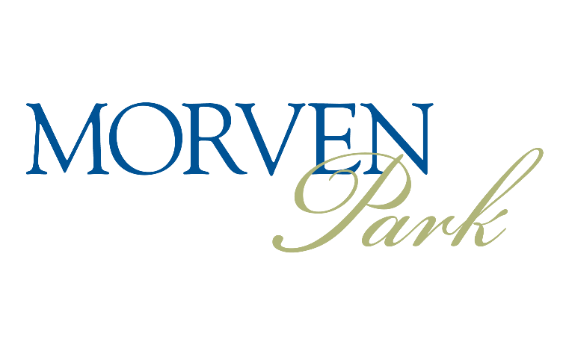
Summer Show Series
May 25
June 22
July 6
July 27
August 17
September 7

$100 Cavalor Hunter Derby at every show!
$250 Derby Finals held at final show!

Series champion awards will be given for all divisions at the September 7th show

Entry fees: $20/class or $50/division
Early entries: $15/class or $45/division
Early entries accepted until 9PM the Wednesday
before each show

For more information, contact Samantha Franklin
Morven Park International Equestrian Center
41580 Sunday Morning Lane
Leesburg, VA 20176
eqoffice@morvenpark.org
(703) 777-2890 ext. 6614

